Recipient’s name
Title
Company name
Address
Email

September 28, 2021

Dear [Full name],

Re. Subject X

Body: The Secretariat of the Global Ocean Accounts Partnership (GOAP) is honoured to support the Indonesian Ministry of Marine Affairs and Fisheries (MMAF) and UK Department for Environment, Food and Rural Affairs (DEFRA) in their capacity as co-hosts of the 3rd Global Dialogue on Ocean Accounting: Towards an Agenda for Action. We are grateful to both co-hosts for their strategic guidance and leadership of the Dialogue, informing the practical organisational support provided by Rekam Nusantara and the GOAP Secretariat. This year’s Dialogue aims to bring together governments, international organizations, research institutions, and other stakeholders and practitioners to (1) explore country experiences with initiating, implementing and using ocean accounts to support policy affecting coastal communities and understanding natural capital, and (2) map out an agenda for collaboration to further ocean accounting efforts among a global community of practice in line with the 2030 Agenda for Sustainable Development, work of the High Level Panel for a Sustainable Ocean Economy, and all relevant national policy commitments.

Sincerely,

Name, title

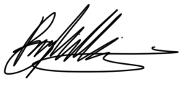

Enclosures

